# CLASS DIAGRAM

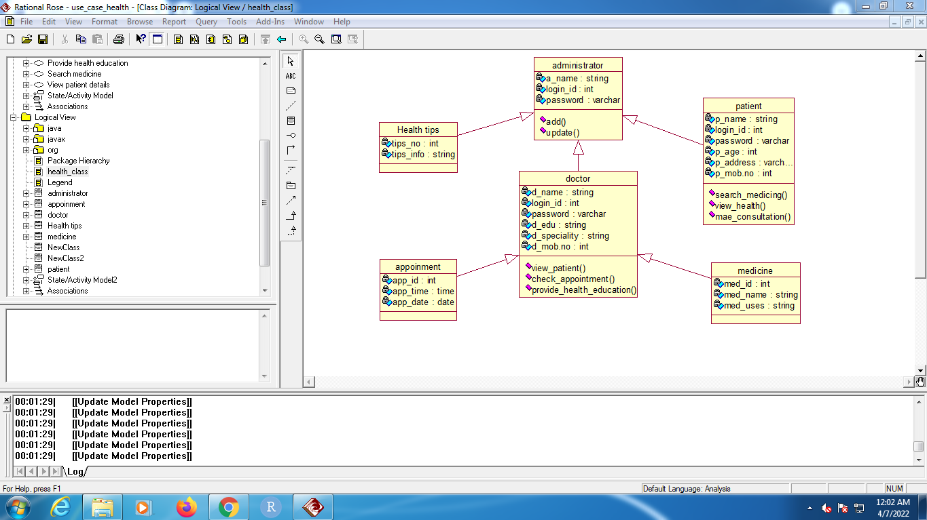

# OBJECT DIAGRAM

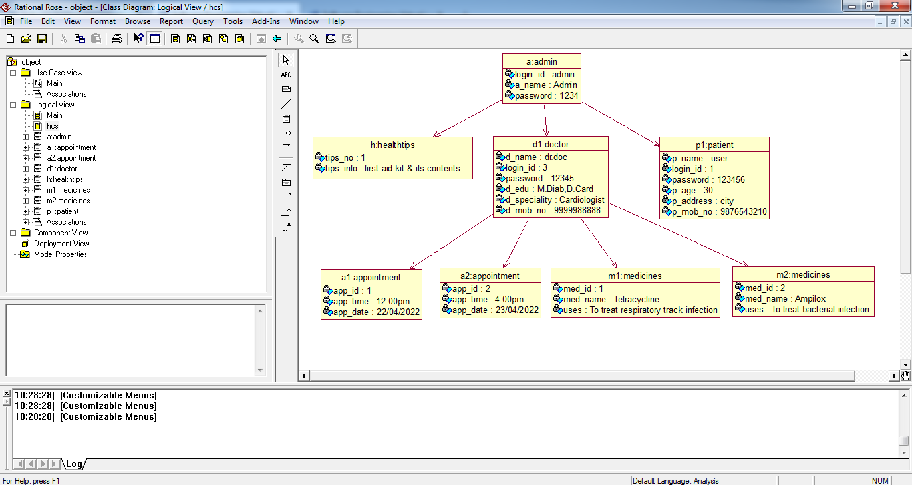

# COMPONENT DIAGRAM

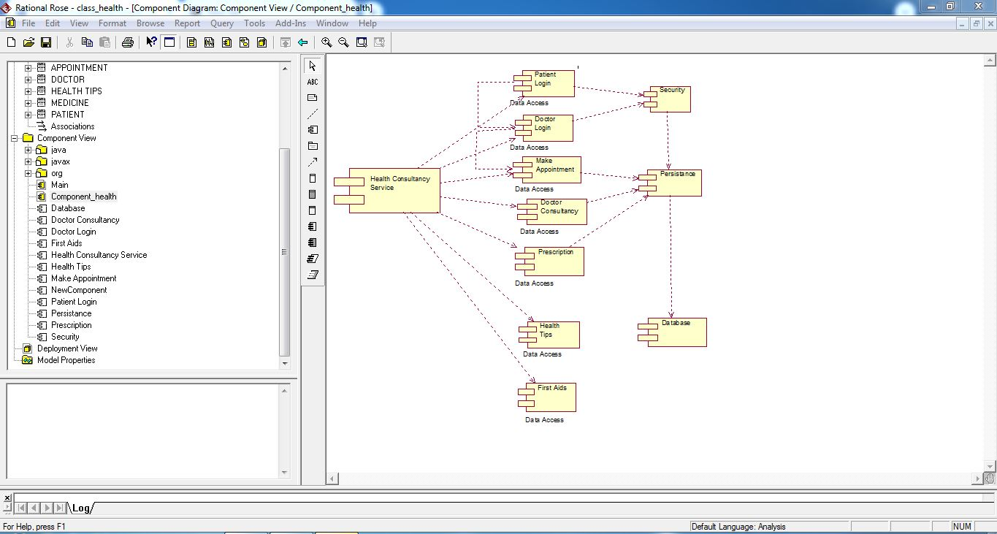

# DEPLOYMENT DIAGRAM

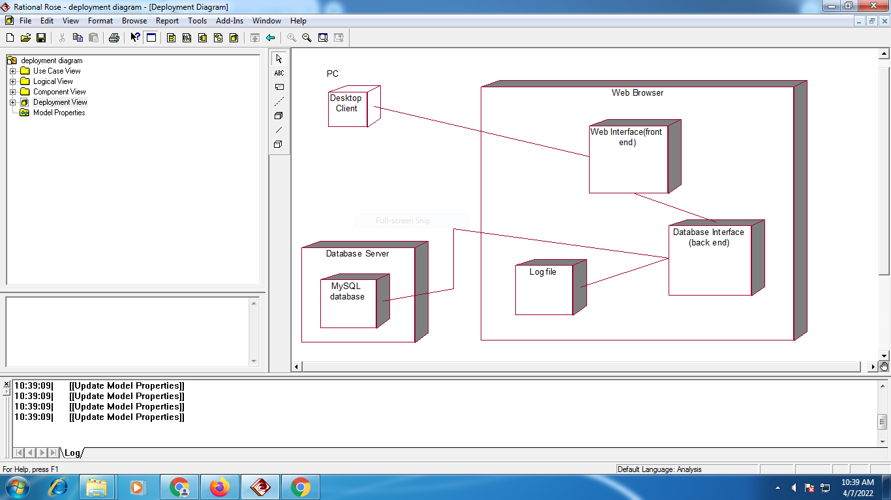

# USE – CASE DIAGRAM

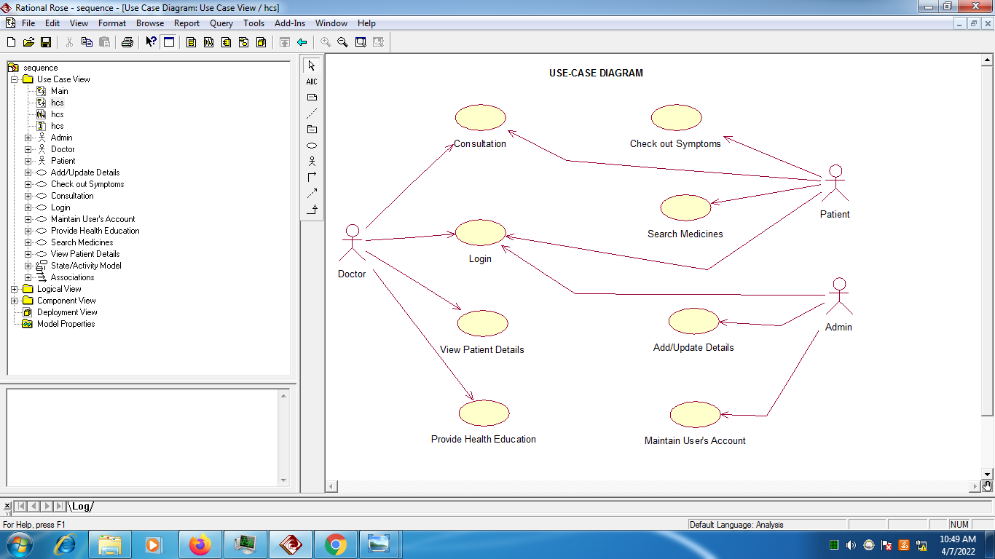

# SEQUENCE DIAGRAM

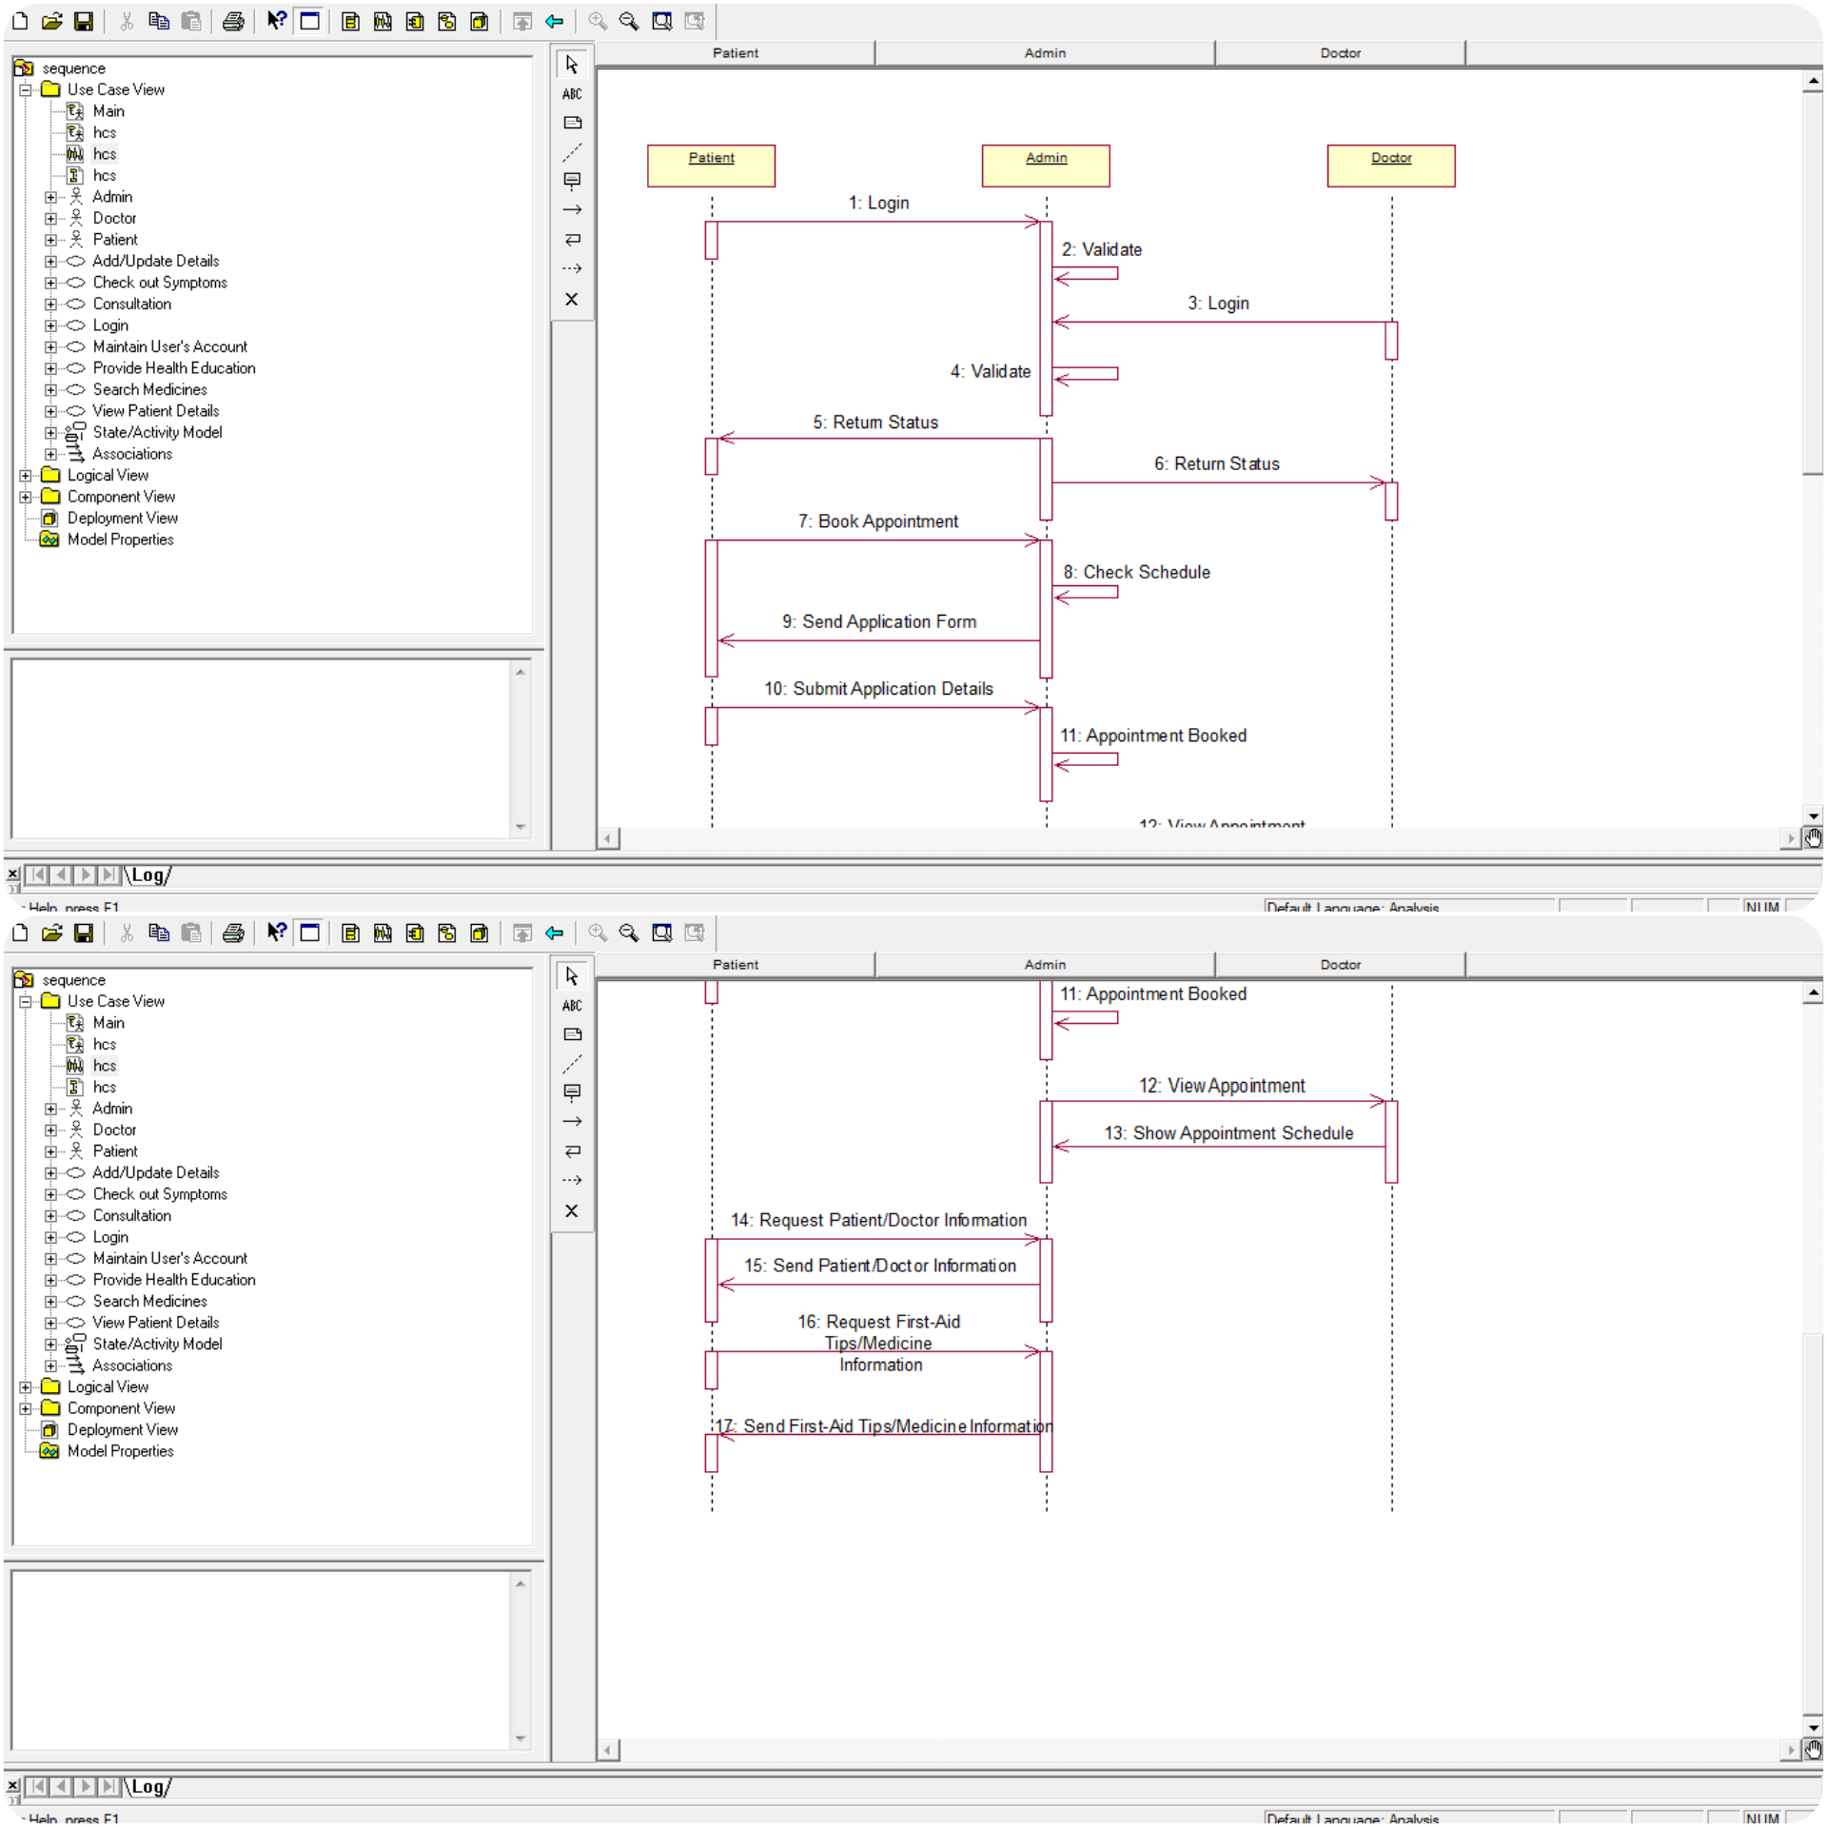

# COLLOBORATIVE DIAGRAM

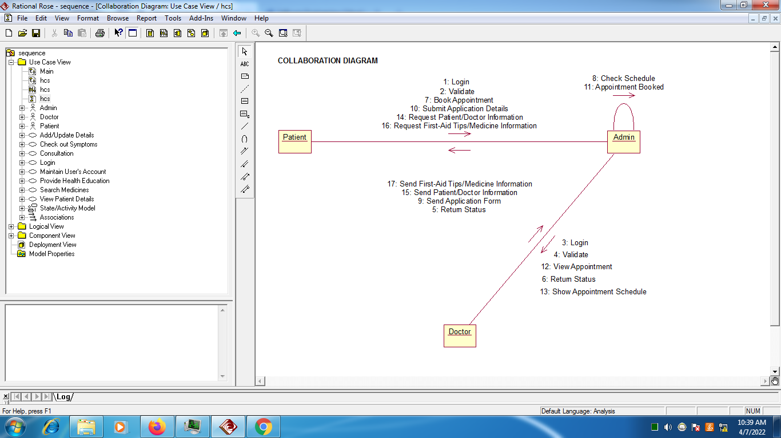

# STATE CHART DIAGRAM

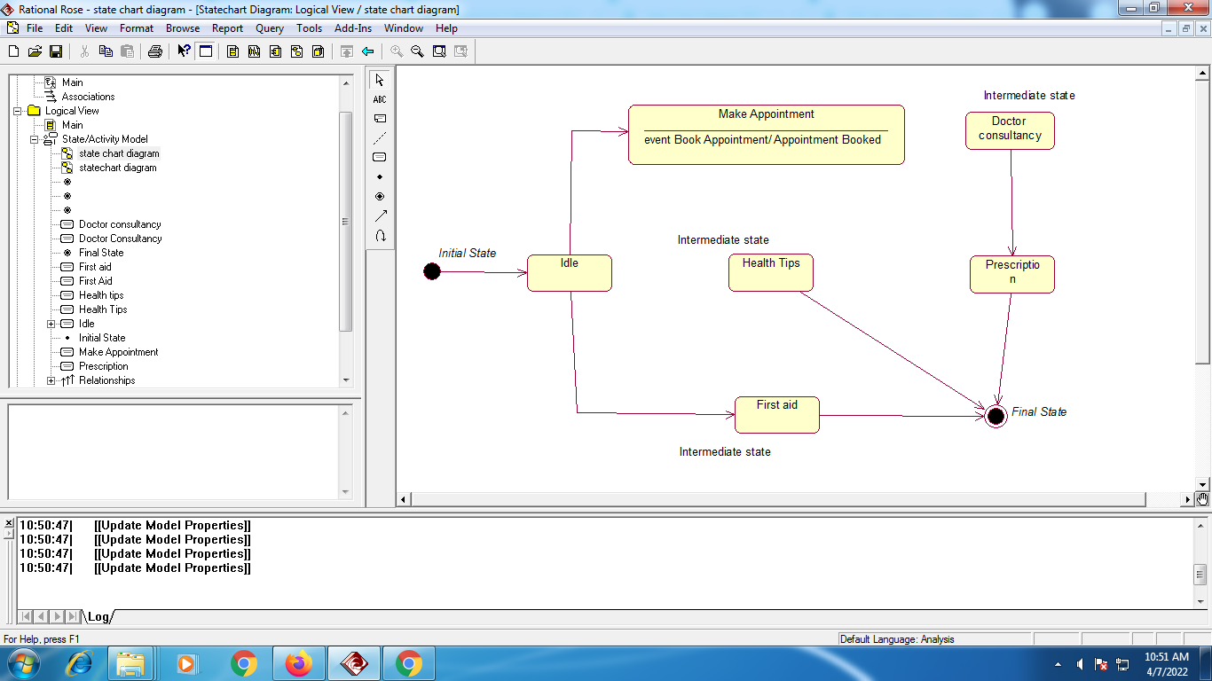

# ACTIVITY DIAGRAM

